Sound Requires a Medium
Solo show, CCA Tel Aviv
January-February 2016
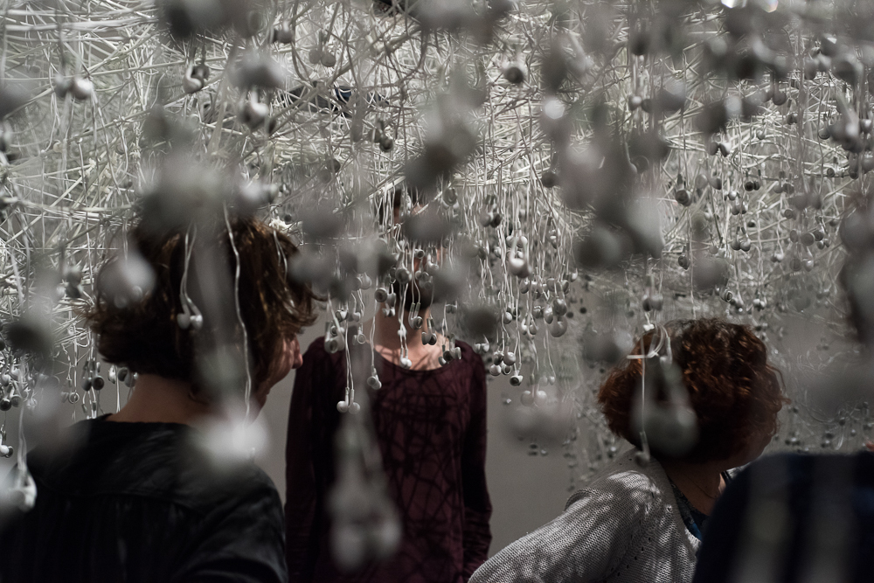
Curator: Chen Tamir

The exhibition Sound Requires a Medium deals with the materiality of sound. It aims to instigate a physical understanding - of the outset, of the essence of sound, and affect the range and depth of the listening experience. Dunietz undermines the traditional perception of visual art as a spatial medium and sound art as time based medium. In a ‘wet’, sensual environment, She creates a unique concoction of the visual and the auditory, cunningly maneuvering and shifting the viewer's perception to follow her as she structures a full, vivid picture from singular fragments of information.

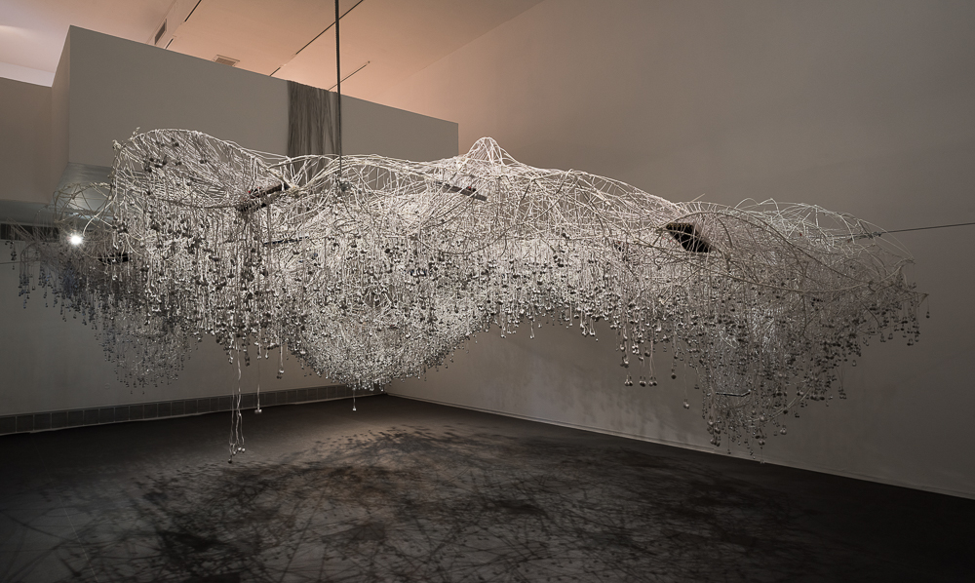

On the first floor, the viewer immerses in a cloud made of thousands of headphones. A look from above unveils the cloud origin, on an upper-level balcony. The thicket floods the space with humming white particles. The sounds coming out of the headphones, as well as the sounds emerging from the balcony of the gallery are an invitation to investigate the space, exposing a unique acoustic phenomena that comes to life as the audience moves around the room. while this Thicket is singing its song other sounds are heard in the space, sounds that we can hear but not yet see, low mumbles and groans and birds echoing from the second floor.

…

In juxtaposition to the immersive experience of the thichket/cloud installation, the second floor of the exhibition is a more fragmented one; four physical anecdotes on space and time that require an increasing level of audience participation. As they challenge the viewer's perception of sound and image, the objects whisper their own private stories. Evidently they also serve as an orchestra- the way the instruments loop into each other is ever changing- they will combine differently on every moment in time.
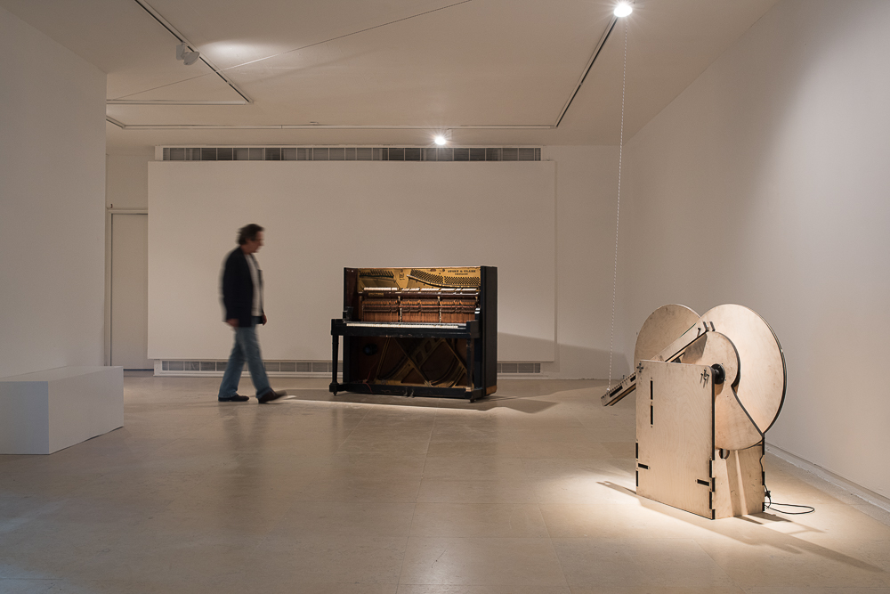
Trembling Piano
The object is an initial confrontation with distorted perception - things are not as they sound. A double bass is recorded playing the piece by dunietz and then played through the trembling of the wooden body of the big Chicago whorehouse piano.

Bird Whistle
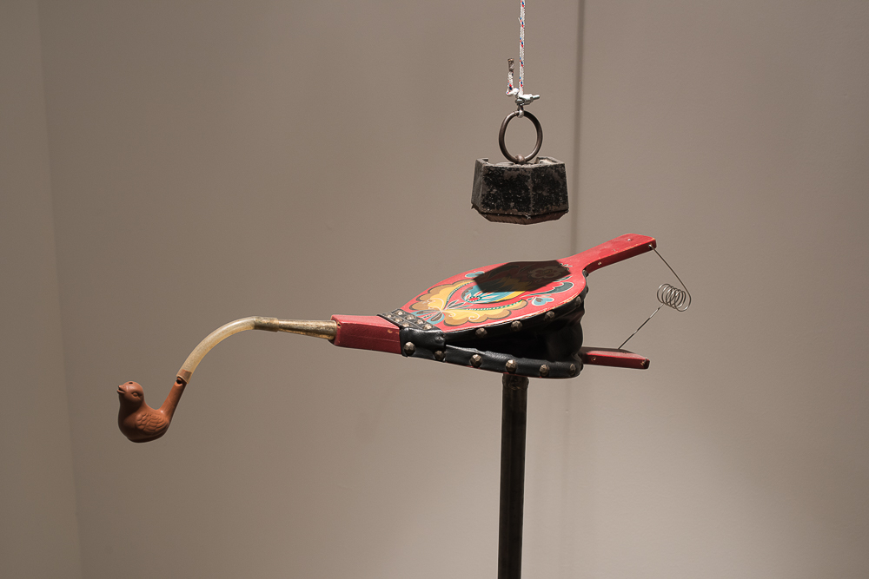
Magical, beautiful hum of a tropical bird echoes throughout the gallery building. As the viewer nears the installation piece it reveals the source of sound - a clumsy mechanical object. The cumbersome process the audience is exposed to through the bird's hum simulates how accustomed we have become to blocking background sound, and points out the vast amount of energy we have to invest in listening to a bird's hum -the most natural, basic experience.

Talking Wall
A hole is carved in the wall of the gallery. If you put your ear in it, you can listen to what's going on inside the wall - a series of intimate recordings, turning the experience of voyeurism on its head. The hole invites to peek into hidden worlds, acting as a sub-conscious layer of the exhibition.
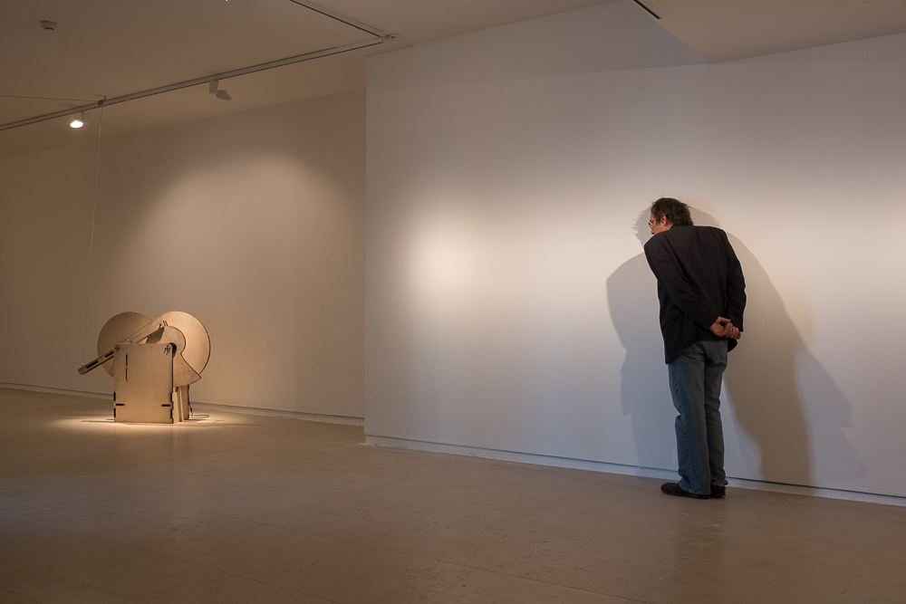
Sound Requires Medium
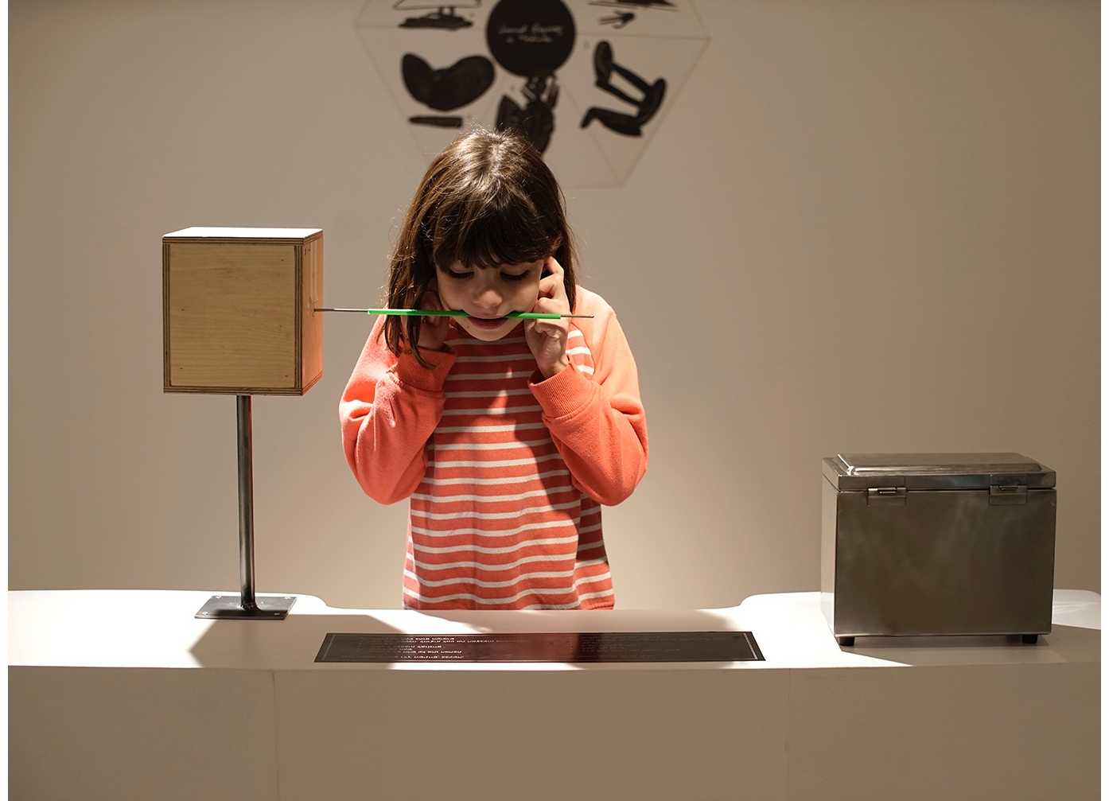
To experience this installation, the audience must wrap the music with their entire body, creating "ears" in the place of other bodily organs. Since listening in this instance bypasses the ears, the deaf can also tune in. The piece played through the rod is a personal feminine song from the artist’s mouth tot the audience’s mouth, a very intimate and personal moment in this public experience. This installation, as with the Trembling Piano, generates a new, unfamiliar, listening experience. The body of the audience wrapped around the piece. The human organ producing sound now takes the role of the one that can hear sound. the audience is then invited to revisit the first installation through another viewpoint in the gallery space, and with a morphed, physical understanding of its auditory layout.

The Artist
Maya Dunietz is a composer, performer and sound artist performing internationally for the past 20 years. She investigates the interconnections between music, visual art, performance, technological research and philosophy. Her works are commissioned by renowned performers and ensembles and she has created site-specific sound- performance works for institutions such as Palais de Tokyo Paris, Arnolfini Gallery Bristol, Reykjavik Arts festival and many more. In 2015 she was guest professor at CALArts LA, as part of the Schusterman residence program. Dunietz received the Prime Minister Composers award in 2015.

